AIM:Design TM using simulator to accept the input string Palindrome ababa

INPUT:

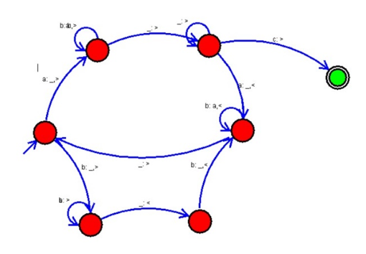

OUTPUT:

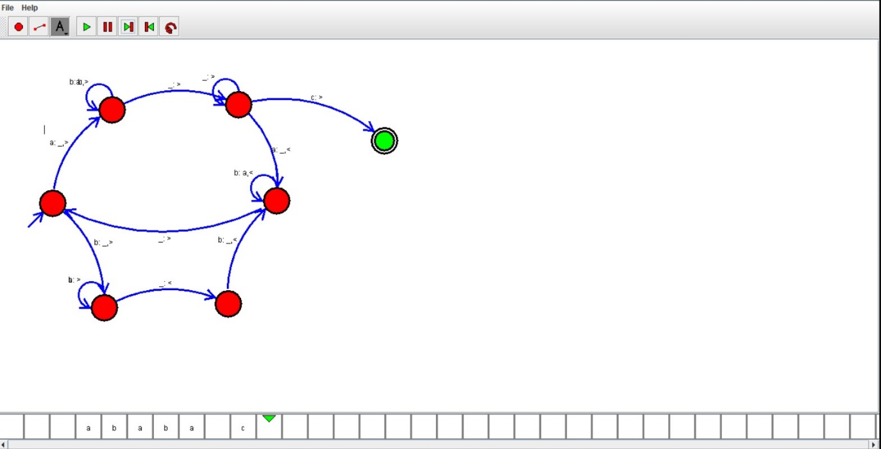

RESULTS:

TM using simulator to accept the input string Palindrome ababa by using autosim